**Build a Serverless App with Cloud Run that Creates PDF Files**

**Overview**

Twelve years ago, Lily started the Pet Theory chain of veterinary clinics. Pet Theory currently sends invoices in DOCX format to clients, but many clients have complained that they are unable to open them. To improve customer satisfaction, Lily has asked Patrick in IT to investigate an alternative to improve the current situation.

Pet Theory's Ops team is a single person, so they are keen to invest in a cost efficient solution that doesn't require a lot of ongoing maintenance. After analyzing the various processing options, Patrick decides to use [Cloud Run](https://cloud.google.com/run/).

Cloud Run is serverless, so it abstracts away all infrastructure management and lets you focus on building your application instead of worrying about overhead. As a Google serverless product, it is able to scale to zero, meaning it won't incur cost when not used. It also lets you use custom binary packages based on containers, which means building consistent isolated artifacts is now feasible.

In this lab you will build a PDF converter web app on Cloud Run that automatically converts files stored in Cloud Storage into PDFs stored in separate folders.

Architecture

This diagram gives you an overview of the services you will be using and how they connect to one another:

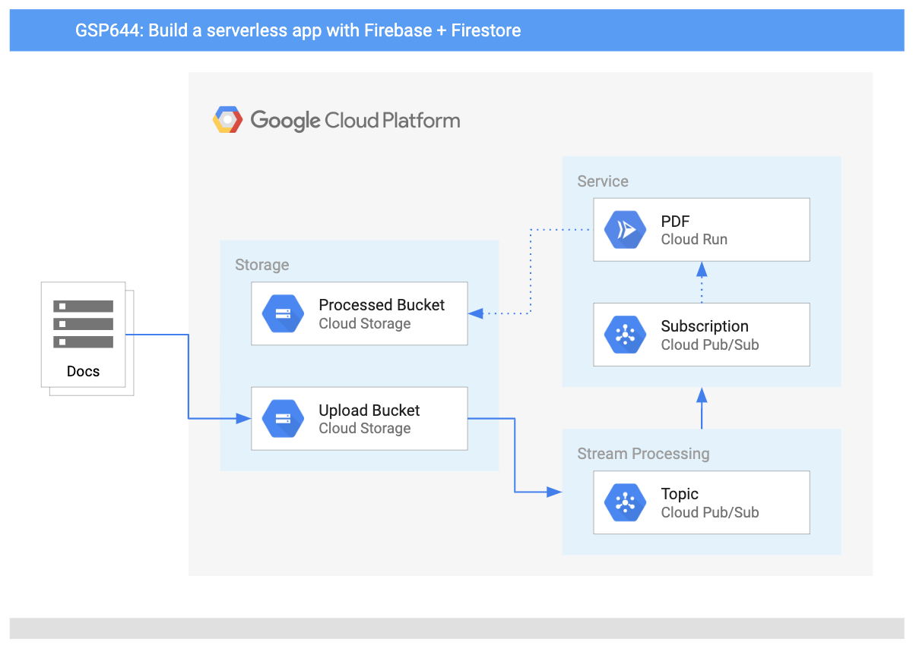

**Objectives**

In this lab, you will learn how to:

* Convert a Node JS application to a container.
* Build containers with Google Cloud Build.
* Create a Cloud Run service that converts files to PDF files in the cloud.
* Use event processing with Cloud Storage

Prerequisites

This is an **intermediate level** lab. This assumes familiarity with the console and shell environments. Experience with Firebase will be helpful, but it is not required. Before taking this lab it is recommended that you have completed the following Google Cloud Skills Boost labs before taking this one:

* [Importing Data to a Firestore Database](https://google.qwiklabs.com/catalog_lab/2163)
* [Build a Serverless Web App with Firebase](https://google.qwiklabs.com/catalog_lab/2166)

Once you're ready, scroll down and follow the steps below to set up your lab environment.

Pet theory would like to convert their invoices into PDFs so that customers can open them reliably. The team wants to accomplish this conversion automatically to minimize the workload for Lisa, the office manager.

Ruby, Pet Theory's computer consultant, gets a message from Patrick in IT...

|  |
| --- |
| Hi Ruby,  I've done some research and found that [LibreOffice](https://www.libreoffice.org/) is good at converting many different file formats to PDF.  Would it be possible to run LibreOffice in the cloud without having to maintain the servers?  Patrick |
| Hey Patrick,  I think I have just the thing for this type of situation.  I just watched a great video from Next 19 about [Cloud Run](https://youtu.be/16vANkKxoAU?t=1317) on YouTube. It looks like we can run LibreOffice in a serverless environment with Cloud Run. No server maintenance is needed!  I'll send over some resources that will help you get set up.  Ruby |

Help Patrick set up and deploy Cloud Run.

Patrick needs to convert a backlog of invoices to PDFs so all customers can open them. He emails Ruby for some help...

|  |
| --- |
| Hi Ruby  Based on your findings, I think we can automate this process and also move to using PDF as the invoice format.  I spent a bit of time yesterday coding a solution and built a Node.js script to do what we need. Could you take a look?  Patrick |

Ruby responds back to Patrick...

|  |
| --- |
| Hi Patrick  Cloud Run uses containers, so we need to provide your application in this format. For the next step we need to create a [Dockerfile manifest](https://source.cloud.google.com/serverless-quest/labs/+/master:lab-3/Dockerfile?authuser=1" \t "blank) for the application.  Your code uses LibreOffice. Can you send me the command for installing that software? I will need to include it in the container.  Ruby |
| Hi Ruby  Awesome, here is how I usually install LibreOffice on servers in the office:  apt-get update -y && apt-get install -y libreoffice && apt-get clean  Let me know if you need any more information.  Patrick |

